February is our Annual Live Music Month
Albert Einstein Academies
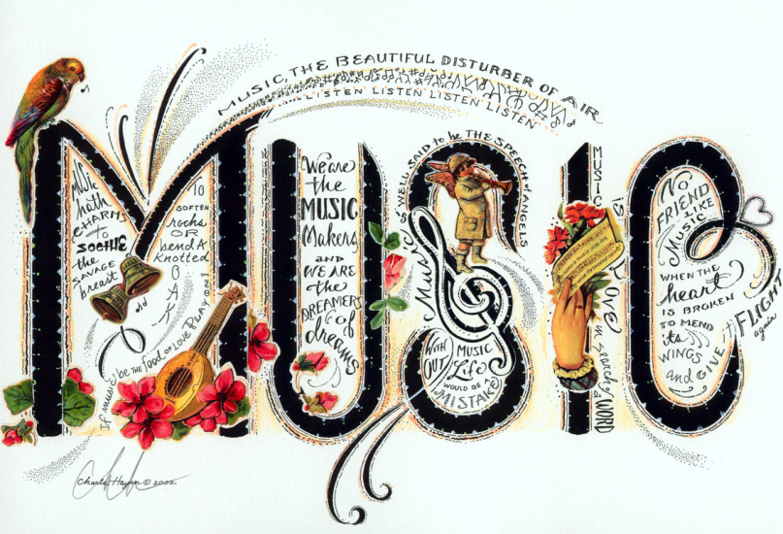
Music is the poetry of the air. ~Richter
Do you play an instrument? Do you love to sing? Are you a songwriter? If so, we want you!

We are excited to bring back our annual Live Music Month at Albert Einstein Academies. We would like to invite musicians and singers to share their talents through the month of February. We have set up times during lunch to allow adults and students to perform and bring music within the walls of our building and into the lives of our learning community.

If you are interested in performing during Live Music Month, please complete the following form and return to the AEA office by January 27, 2012 .

You will be contacted by an AEA program coordinator to confirm your interest and participation details. All performances will take place in the Multi Purpose Room (MPR).
Name:_____________________________________________________________
What is your connection to AEA:___________________________________________
Email:_________________________ Telephone number:______________________
What is your musical talent? ______________________________________________
What would you like to perform? (song titles, artists) _____________________________
__________________________________________________________________
How long will your performance take?(15 mn.max) ______________________________
What are your top two preferred performance times (Please circle below)
Performance days/times:
2-7: 11:30am -12:00pm 12:10-12:40pm
2-9: 11:30am -12:00pm 12:10-12:40pm
2-14: 11:30am -12:00pm 12:10-12:40pm
2-21: 11:30am -12:00pm 12:10-12:40pm
2-23: 11:30am -12:00pm 12:10-12:40pm

Equipment: We have an amp with chord for guitar, a piano, and microphone and stage.
What will you need? ___________________________________________________
__________________________________________________________________

