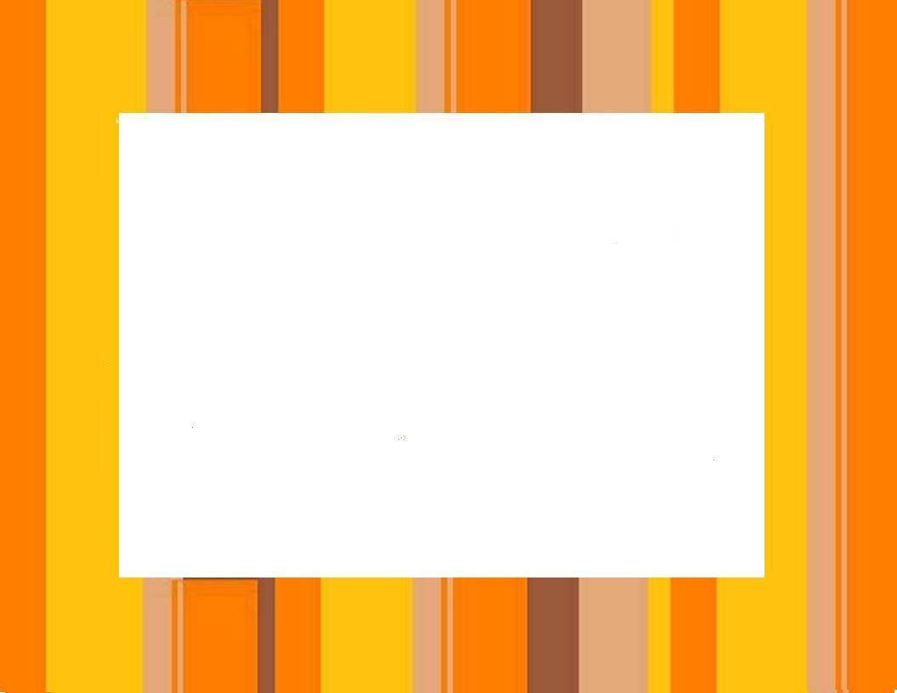
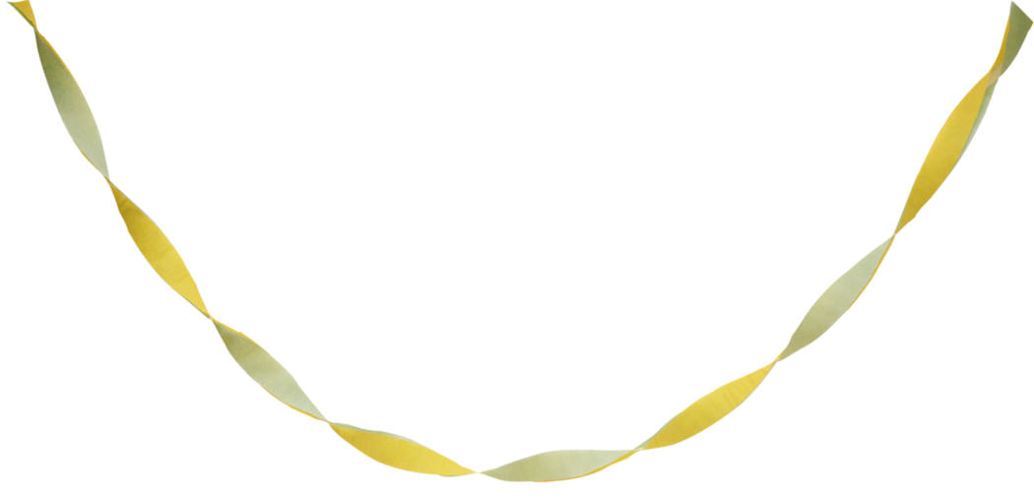

Good for one
German Meal
at the
80’s Disco Party
Saturday, 30 April, 7:00 pm
At the German American Society

