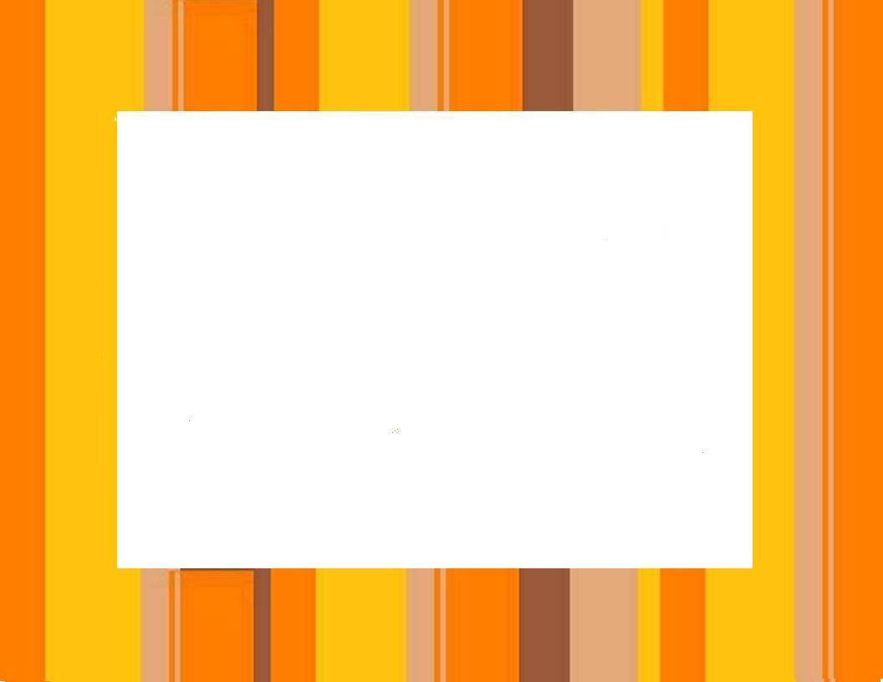
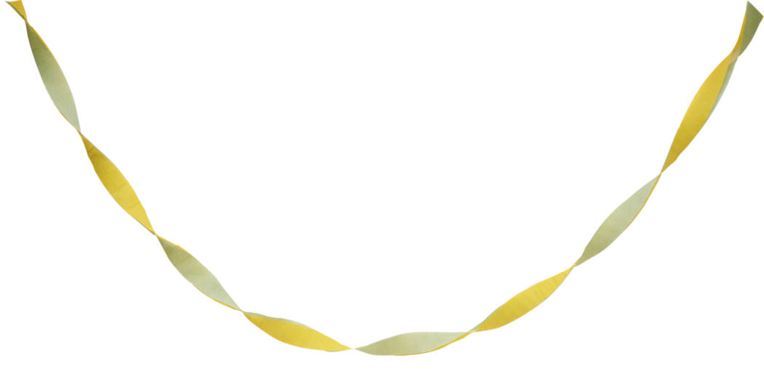

80’s Disco Party
Saturday, 30 April, 7:00 pm
At the German-American Society
1017 South Mollison Ave
El Cajon, 92020

Ticket includes snacks and soft drinks

